Project Development Phase
Model Performance Test

DATE | 26-06-26
PROJECT NAME | SB Stocks is a user-friendly web app built for stock market enthusiasts
MAXIMUM MARKS
Model Performance Testing:
Project team shall fill the following information in model performance testing template.
S.No. | Parameter | Screenshot / Values
 | Data Rendered | 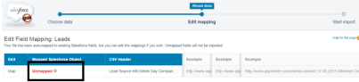
 | Data Preprocessing | 
3. | Utilization of Filters | 
4. | Calculation fields Used | 
5. | Dashboard design | No of Visualizations / Graphs -
6 | Story Design | No of Visualizations / Graphs -

